**Age Distribution:**

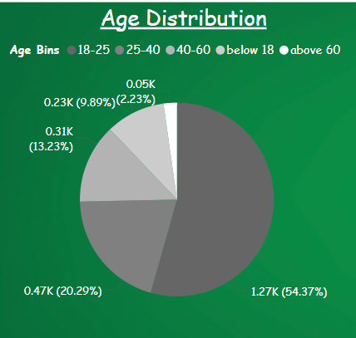

* The largest age group is **18-25**, making up **54.37%** of the total respondents, indicating that a significant portion of the population is young.
* The next significant group is **40-60**, contributing **20.29%**, followed by **25-40** with **13.23%**.
* Smaller proportions include people **above 60** (9.89%) and those **below 18** (2.23%).

**Duration of Residency Distribution:**

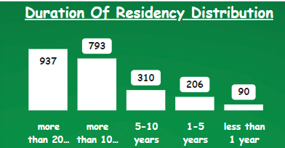

* **937** respondents have lived in the area for **more than 20 years**, making this the largest group.
* **793** people have lived in the area for **more than 10-20 years**.
* The next groups include **310** for **5-10 years**, **206** for **1-5 years**, and **90** for **less than 1 year**, indicating that a large portion of the population has been in the area for an extended period.

**Profession Distribution:**

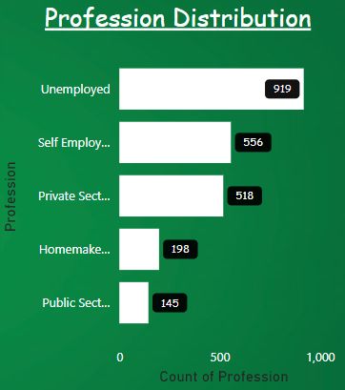

* A significant portion of respondents, **919**, are **unemployed**, indicating a high level of unemployment in this population.
* **Self-employed** individuals account for **556**, followed closely by **private sector employees** at **518**.
* Smaller groups include **homemakers** (**198**) and **public sector employees** (**145**).

**Gender Distribution:**

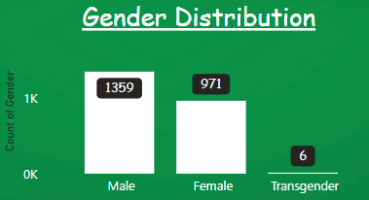

* There is a higher number of **males** (**1359**) compared to **females** (**971**), indicating a male-dominated population.
* **6** respondents identify as **transgender**.

**Total Responses:**

* There are **2336** total responses, which provides a good sample size for insights and decision-making.

**BEST BUS IMPORTNACE:**

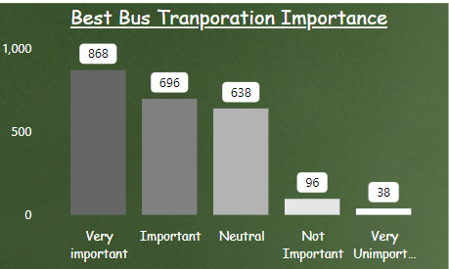

* The majority, **868 respondents**, consider bus transportation to be **"Very important"**, indicating a strong reliance or value placed on bus services.
* **696 respondents** find it **"Important"**, further suggesting that most respondents (over 65%) see bus transportation as essential.
* **638 respondents** are **"Neutral"**, showing that a significant portion of the population may have no strong opinion about bus transportation.
* A smaller group, **96 respondents**, believe it is **"Not Important"**.
* Only **38 respondents** consider bus transportation to be **"Very Unimportant"**.

**Key Insight:**

The overwhelming majority of respondents (over 66%) consider bus transportation either **Very Important** or **Important**, highlighting the necessity of maintaining or improving bus services for the population.

USERS OPINIONS ON USING AUTORICKSHAW:

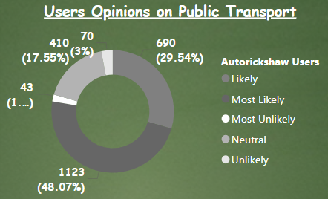

* The majority of respondents, **1,123** (48.07%), are **most likely** to use public transport, indicating strong reliance on it.
* **690** users (29.54%) are **likely** to use public transport, further emphasizing its importance.
* A smaller group, **410** respondents (17.55%), are **neutral** toward public transport.
* **70** respondents (3%) are **most unlikely** to use public transport, while **43** (1.84%) are **unlikely**, indicating a small percentage of users who don’t prefer public transport.

USERS OPINIONS ON USING BEST BUS:

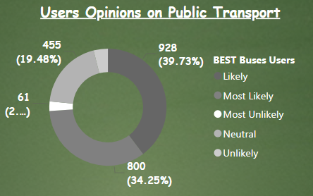

* Most Likely: 39.73% (928 users)
* Likely: 34.25% (800 users)
* Neutral: 19.48% (455 users)
* Unlikely: 3.94% (92 users)
* Most Unlikely: 2.61% (61 users)
* Positive sentiment: The combined "Most Likely" and "Likely" categories account for 73.98% of responses, indicating a strong positive sentiment towards public transport among BEST Buses Users.
* Low negative sentiment: Only 6.55% of users fall into the "Unlikely" or "Most Unlikely" categories, suggesting very low dissatisfaction with the service.
* Neutral stance: A significant portion (19.48%) remains neutral, which could represent potential for improvement or users who are satisfied but not enthusiastic.

USERS OPINIONS ON USING METRO:

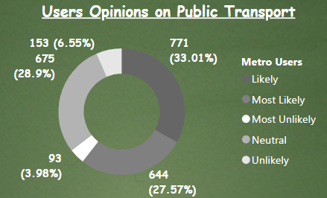

1. **Likely**: Represented by blue, 771 users (33.01%) indicated that they are likely to use public transport.
2. **Most Likely**: In dark blue, 644 users (27.57%) expressed that they are most likely to use it.
3. **Neutral**: Represented by purple, 675 users (28.9%) are neutral about using public transport.
4. **Unlikely**: In pink, 153 users (6.55%) are unlikely to use public transport.
5. **Most Unlikely**: Orange indicates that 93 users (3.98%) are most unlikely to use public transport.

* The majority of users are either likely (33.01%) or most likely (27.57%) to use public transport, making up about 60.58% in total.
* A significant portion (28.9%) remains neutral, suggesting that nearly one-third of users are indifferent or undecided.
* Only a small percentage (6.55% + 3.98% = 10.53%) of users express a reluctance to use public transport.

USERS OPINIONS ON USING MUMBAI LOCAL TRAINS:

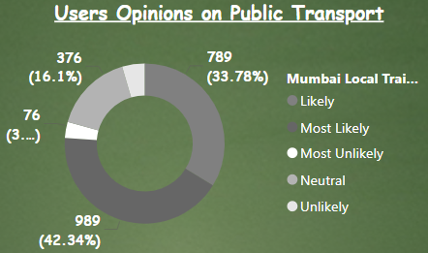

1. **Likely**: Represented by blue, 789 users (33.78%) indicated they are likely to use public transport.
2. **Most Likely**: The dark blue segment shows that 989 users (42.34%) are most likely to use it.
3. **Neutral**: Purple represents 376 users (16.1%) who are neutral about public transport.
4. **Unlikely**: In pink, 106 users (4.54%) indicated they are unlikely to use public transport.
5. **Most Unlikely**: The orange segment, accounting for 76 users (3.25%), represents those most unlikely to use it.

**Insights:**

* A significant majority (42.34% most likely + 33.78% likely = 76.12%) of Mumbai local train users are inclined to use public transport.
* The neutral segment (16.1%) is considerably smaller compared to the first chart, indicating that fewer people are undecided about their stance.
* Only a small percentage (4.54% unlikely + 3.25% most unlikely = 7.79%) are hesitant to use public transport.

USERS OPINIONS ON USING TAXI USERS:

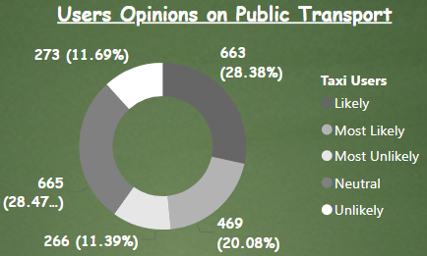

1. **Likely**: The blue segment shows 663 users (28.38%) who are likely to use public transport.
2. **Most Likely**: Dark blue indicates 665 users (28.47%) are most likely to use public transport.
3. **Neutral**: The purple section shows 273 users (11.69%) who are neutral toward public transport.
4. **Unlikely**: In pink, 266 users (11.39%) are unlikely to use public transport.
5. **Most Unlikely**: The orange section shows 469 users (20.08%) as the most unlikely to use public transport.

**Insights:**

* **Most Likely and Likely**: A combined 56.85% (28.47% most likely + 28.38% likely) of taxi users are positive about using public transport.
* **Neutral Segment**: The neutral group (11.69%) is smaller compared to the other categories.
* **Unlikely and Most Unlikely**: 31.47% (11.39% unlikely + 20.08% most unlikely) of taxi users are hesitant or resistant to using public transport

FREQUNET BEST BUS USAGE:

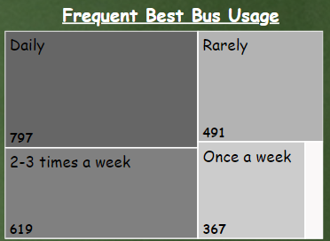

1. Daily users: This is the largest group, represented by the biggest box in the top left corner. 797 people use the bus daily.
2. 2-3 times a week: The second largest group, with 619 users falling into this category.
3. Rarely: 491 people use the bus rarely.
4. Once a week: 367 individuals use the bus once a week.
5. Never: The smallest group, with 62 people never using the bus service.

**Insights:**

1. Regular users dominate: The majority of people use the bus frequently (daily or 2-3 times a week), indicating a strong reliance on public transportation for many.
2. Daily commuters: The large number of daily users (797) suggests that many people depend on the bus for their everyday commute, possibly for work or school.

PUBLIC TRANSPORT USERS:

1. 2195 of the people use public transport in Mumbai.
2. 141 of the people maybe use public transport in Mumbai
3. There are no people who do not use public transport in Mumbai.

HOW DO YOU USUALLY TRAVEL ON THE BEST BUS?

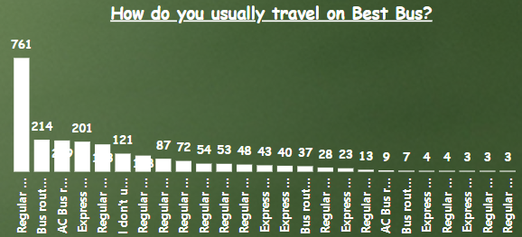

1. Most common mode: By far, the most frequent way people travel is using "Regular Bus routes connecting Mumbai," with 761 respondents.
2. Other popular options:

* AC Bus routes within Mumbai: 214 users
* Express Bus routes within Mumbai: 209 users
* Regular Bus routes within Mumbai: 201 users
* Regular AC Bus routes within Mumbai: 183 users

1. Less common options: The chart shows a long tail of less frequently used options, including various combinations of regular, AC, and express bus routes within Mumbai and connecting to other areas.

Insights:

* Regular bus routes are the backbone of the service, particularly for connecting different parts of Mumbai.
* There's significant demand for AC and express services within the city.

USERS OPINONS ON PUBLIC TRASNPORT [TRAVELLING WITH LUGGAGE]

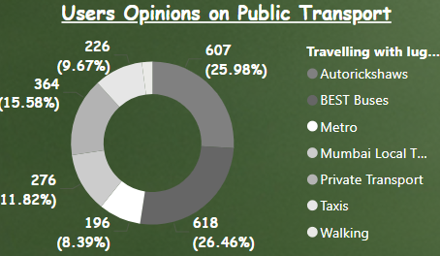

1. BEST Buses: 26.46% (618 users)
2. Autorickshaws: 25.98% (607 users)
3. Private Transport: 15.58% (364 users)
4. Mumbai Local Trains: 11.82% (276 users)
5. Taxis: 9.67% (226 users)
6. Metro: 8.39% (196 users)
7. Walking: 2.1% (49 users)

Key insights:

1. Public transport dominance: BEST Buses and Autorickshaws together account for over 52% of preferences, showing strong reliance on public transport options.
2. Diverse preferences: The chart shows a good spread across various modes, indicating that users have and use multiple options for luggage travel.
3. Train usage: Combined, Mumbai Local Trains and Metro make up about 20% of preferences, suggesting significant use of rail systems despite potential crowding issues.
4. Private options: Private Transport and Taxis together account for about 25%, indicating a substantial portion of users prefer or require more personalized transport options.

USERS OPINONS ON PUBLIC TRASNPORT [TRAVELLING TO SCHOOL]

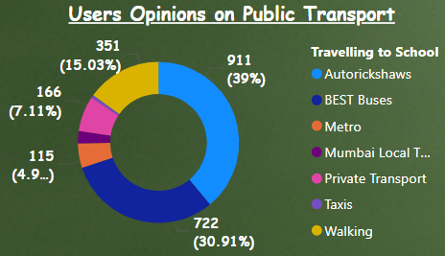

1. Autorickshaws: 39% (911 users)
2. BEST Buses: 30.91% (722 users)
3. Walking: 15.03% (351 users)
4. Private Transport: 7.11% (166 users)
5. Metro: 4.92% (115 users)
6. Mumbai Local Trains: 2.44% (57 users)
7. Taxis: 0.6% (14 users)

Key insights:

1. Dominance of affordable public transport: Autorickshaws and BEST Buses together account for nearly 70% of preferences, indicating a strong reliance on these accessible and potentially more affordable options for school travel.
2. Walking popularity: A significant portion (15.03%) of students walk to school, suggesting many live within walking distance of their educational institutions.
3. Limited use of rail systems: Despite Mumbai's extensive rail network, Mumbai Local Trains and Metro combined only account for about 7.36% of school travel preferences.
4. Low taxi usage: Taxis are rarely used for school travel, likely due to cost factors and the availability of more suitable alternatives.
5. Private transport: While not the most popular, private transport still accounts for a notable 7.11%, possibly indicating some families prefer or require this option.

USERS OPINONS ON PUBLIC TRASNPORT [TRAVELLING TO COLLEGE]

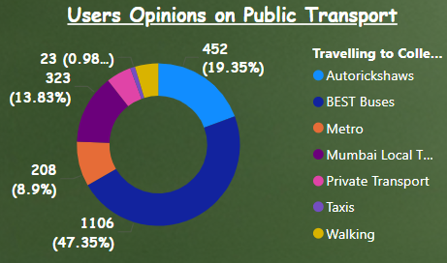

1. BEST Buses: 47.35% (1106 users)
2. Autorickshaws: 19.35% (452 users)
3. Mumbai Local Trains: 13.83% (323 users)
4. Metro: 8.9% (208 users)
5. Private Transport: 4.97% (116 users)
6. Walking: 4.62% (108 users)
7. Taxis: 3.64% (85 users)

Key insights:

1. Dominance of BEST Buses: Nearly half of college students prefer BEST Buses, indicating their crucial role in college transportation.
2. Public transport reliance: Combining BEST Buses, Autorickshaws, Mumbai Local Trains, and Metro, about 89.43% of college students use public transportation.
3. Significant train usage: Mumbai Local Trains and Metro together account for 22.73% of preferences, showing the importance of rail systems for college commutes.
4. Reduced walking: Compared to school travel, walking is much less common for college trips, likely due to longer distances.
5. Limited private transport: Only about 5% use private transport, suggesting most college students rely on public options.

USERS OPINONS ON PUBLIC TRASNPORT [TRAVELLING DURING HOLIDAYS]

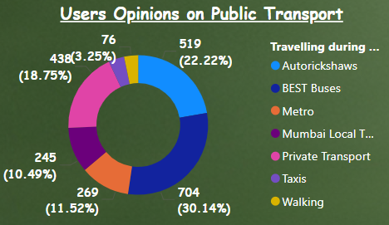

1. BEST Buses: 30.14% (704 users)
2. Autorickshaws: 22.22% (519 users)
3. Private Transport: 18.75% (438 users)
4. Mumbai Local Trains: 11.52% (269 users)
5. Metro: 10.49% (245 users)
6. Taxis: 3.64% (85 users)
7. Walking: 3.25% (76 users)

Key insights:

1. Dominance of BEST Buses: BEST Buses are the most preferred mode, accounting for 30.14% of holiday travel choices, highlighting their importance in public transportation.
2. Public transport reliance: Combining BEST Buses, Autorickshaws, Mumbai Local Trains, and Metro, about 74.37% of users prefer public transportation for holiday travel.
3. Significant auto usage: Autorickshaws are the second most popular option at 22.22%, indicating their convenience for holiday trips.
4. Private transport popularity: Unlike regular commutes, private transport is the third most preferred option at 18.75%, suggesting a higher use of personal vehicles or hired cars during holidays.

USERS OPINONS ON PUBLIC TRASNPORT [TRAVELLING DURING FESTIVALS]

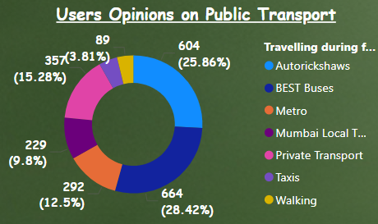

1. BEST Buses: 28.42% (664 users)
2. Autorickshaws: 25.86% (604 users)
3. Private Transport: 15.28% (357 users)
4. Metro: 12.5% (292 users)
5. Mumbai Local Trains: 9.8% (229 users)
6. Taxis: 4.32% (101 users)
7. Walking: 3.81% (89 users)

Key insights:

1. Dominance of BEST Buses: BEST Buses are the most preferred mode for festival travel, accounting for 28.42% of choices, highlighting their importance in public transportation during festive seasons.
2. Strong preference for Autorickshaws: Autorickshaws are a close second at 25.86%, indicating their convenience and accessibility during festivals.
3. Public transport reliance: Combining BEST Buses, Autorickshaws, Metro, and Mumbai Local Trains, about 76.58% of users prefer public transportation for festival travel.
4. Significant private transport use: Private transport is the third most popular option at 15.28%, suggesting a notable preference for personal vehicles or hired cars during festivals.
5. Metro popularity: The Metro system is more popular than Mumbai Local Trains for festival travel, possibly due to comfort or convenience factors.
6. Limited walking and taxi use: Walking (3.81%) and taxis (4.32%) are the least preferred options, likely due to the nature of festival travel involving longer distances or the need to carry items.

USERS OPINONS ON PUBLIC TRASNPORT [TRAVELLING ALONE]

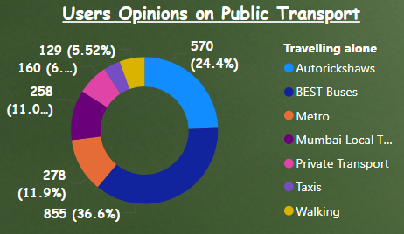

1. BEST Buses: 36.6% (855 users)
2. Autorickshaws: 24.4% (570 users)
3. Metro: 11.9% (278 users)
4. Mumbai Local Trains: 11.04% (258 users)
5. Private Transport: 6.85% (160 users)
6. Walking: 5.52% (129 users)
7. Taxis: 3.68% (86 users)

Key insights:

1. Dominance of BEST Buses: BEST Buses are overwhelmingly preferred for traveling alone, accounting for 36.6% of choices. This indicates their reliability, accessibility, and possibly cost-effectiveness for individual travellers.
2. Strong preference for Autorickshaws: Autorickshaws are the second most popular option at 24.4%, suggesting their convenience for solo trips, especially for shorter distances or areas with less bus connectivity.
3. High reliance on public transport: Combining BEST Buses, Autorickshaws, Metro, and Mumbai Local Trains, about 83.94% of users prefer public transportation when traveling alone. This shows a robust public transport system that caters well to individual travelers.
4. Metro slightly more popular than Local Trains: The Metro (11.9%) is marginally preferred over Mumbai Local Trains (11.04%) for solo travel, possibly due to factors like comfort, speed, or route coverage.
5. Limited use of private transport: Only 6.85% opt for private transport when traveling alone, which could include personal vehicles or ride-hailing services. This low percentage might be due to cost considerations or traffic concerns for solo travellers.
6. Walking as a viable option: 5.52% of users choose to walk, indicating that a noticeable portion of solo trips are for shorter distances or in pedestrian-friendly areas.
7. Least preference for taxis: Taxis are the least preferred option at 3.68%, possibly due to higher costs compared to other available public transport options.

USERS OPINONS ON PUBLIC TRASNPORT [SOCIAL COMMUTE]

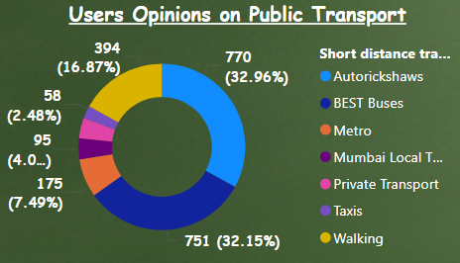

1. BEST Buses: 36.6% (855 users)
2. Autorickshaws: 24.4% (570 users)
3. Metro: 11.9% (278 users)
4. Mumbai Local Trains: 11.04% (258 users)
5. Private Transport: 6.85% (160 users)
6. Walking: 5.52% (129 users)
7. Taxis: 3.68% (86 users)

Key insights:

1. Public transport dominance: BEST Buses, Autorickshaws, Metro, and Mumbai Local Trains collectively account for 83.94% of preferences, showing a strong reliance on public transportation for solo travel.
2. BEST Buses lead: With 36.6% preference, BEST Buses are the most popular choice, likely due to their extensive network, affordability, and reliability.
3. Autorickshaws' popularity: At 24.4%, autorickshaws are the second most preferred option, suggesting their convenience for shorter trips or areas with less bus coverage.
4. Metro vs Local Trains: The Metro (11.9%) is slightly more popular than Mumbai Local Trains (11.04%) for solo travellers, possibly due to comfort or specific route preferences.
5. Limited private transport use: Only 6.85% opt for private transport when traveling alone, which might include personal vehicles or ride-hailing services.
6. Walking as an option: 5.52% of users choose to walk, indicating that a notable portion of solo trips are for shorter distances or in pedestrian-friendly areas.
7. Least preference for taxis: Taxis are the least preferred option at 3.68%, possibly due to higher costs compared to other available public transport options.

USERS OPINONS ON PUBLIC TRASNPORT [SOCIAL COMMUTE WITH FRIENDS]

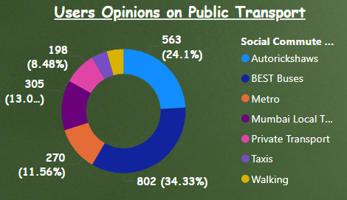

1. BEST Buses: 34.33% (802 users)
2. Autorickshaws: 24.1% (563 users)
3. Private Transport: 13.06% (305 users)
4. Metro: 11.56% (270 users)
5. Mumbai Local Trains: 8.48% (198 users)
6. Walking: 4.37% (102 users)
7. Taxis: 4.11% (96 users)

Key insights:

1. Preference for BEST Buses: BEST Buses are the most popular choice for social commutes with friends, accounting for 34.33% of preferences. This suggests they're seen as convenient and cost-effective for group travel.
2. Strong showing for Autorickshaws: At 24.1%, autorickshaws are the second most preferred option, likely due to their flexibility and ability to accommodate small groups.
3. Significant use of public transport: Combining BEST Buses, Autorickshaws, Metro, and Mumbai Local Trains, about 78.47% of users prefer public transportation for social commutes with friends.
4. Rise in private transport: Compared to solo travel, there's an increase in private transport usage (13.06%), possibly due to the ease of cost-sharing among friends.
5. Metro more popular than Local Trains: The Metro (11.56%) is preferred over Mumbai Local Trains (8.48%) for social commutes, perhaps due to comfort or specific route preferences.
6. Limited walking and taxi use: Walking (4.37%) and taxis (4.11%) are the least preferred options, likely due to group size considerations and cost factors respectively.

USERS OPINONS ON PUBLIC TRASNPORT [SHORT DISTANCE TRAVELS]



1. Most popular modes: The two most preferred methods of transport are Autorickshaws (32.96%) and BEST Buses (32.15%), which together account for about 65% of user preferences.
2. Walking is significant: Walking is the third most popular option at 16.87%, indicating a substantial number of people prefer or need to walk for short distances.
3. Metro usage: The Metro system is used by 7.49% of users, which is notable but much lower than traditional modes like buses and autorickshaws.
4. Low private transport use: Private transport (likely referring to personal vehicles) is relatively low at 3.98%, suggesting a strong reliance on public transportation options.
5. Mumbai Local Trains: Despite Mumbai being famous for its local train system, it's only preferred by 4.07% for short distance travel, possibly because the chart focuses on short distances where other modes might be more convenient.
6. Taxis least preferred: Taxis are the least preferred option at 2.48%, possibly due to cost or availability compared to other options.

USERS OPINONS ON PUBLIC TRASNPORT [ROAMING AROUND THE CITY IN MORNING]

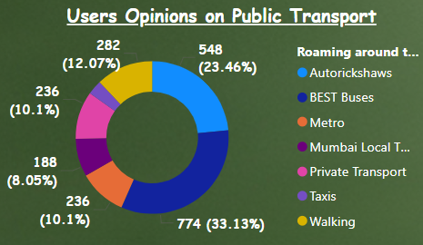

1. Most popular modes: The two most preferred methods of transport are Mumbai Local Trains (33.13%) and BEST Buses (23.46%), which together account for about 56.59% of user preferences.
2. Walking is significant: Walking is preferred by 3.08% of users.
3. Metro usage: The Metro system is used by 8.05% of users.
4. Low private transport use: Private transport is used by 10.1% of users.
5. Mumbai Local Trains: Mumbai Local Trains are preferred by 33.13% of users, making them the most popular mode of transport.
6. Taxis least preferred: Taxis are preferred by 10.1% of users, tying with Private Transport and not actually being the least preferred option.

USERS OPINONS ON PUBLIC TRASNPORT [ROAMING AROUND THE CITY IN NIGHT]

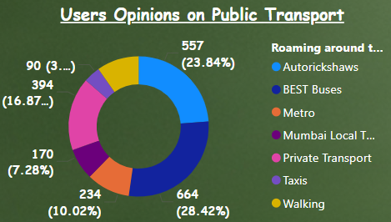

1. Most popular modes: The two most preferred methods of transport are Mumbai Local Trains (28.42%) and BEST Buses (23.84%), which together account for over 50% of user preferences.
2. Walking is significant: Walking is the sixth most popular option at 7.28%, indicating a smaller number of people prefer or need to walk for short distances.
3. Metro usage: The Metro system is used by 9.72% of users, which is notable but lower than traditional modes like buses and local trains.
4. Low private transport use: Private transport is relatively low at 16.87%, suggesting a moderate reliance on public transportation options.
5. Mumbai Local Trains: Mumbai Local Trains are the most preferred option, highlighting their importance in the city's transport system.
6. Taxis least preferred: Taxis are the least preferred option at 10.02%, possibly due to cost or availability compared to other options.

USERS OPINONS ON PUBLIC TRASNPORT [LONG DISTNACE TRAVELLING]

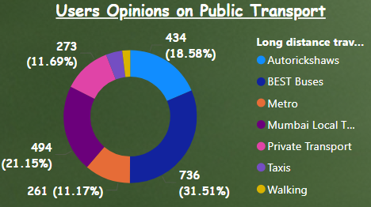

1. **Most popular modes:** The two most preferred methods of transport are Mumbai Local Trains (31.51%) and BEST Buses (18.58%), which together account for over 50% of user preferences.
2. **Walking is significant:** Walking is the fifth most popular option at 11.17%, indicating a notable number of people prefer or need to walk for short distances.
3. **Metro usage:** The Metro system is used by 11.69% of users, which is notable but lower than traditional modes like buses and local trains.
4. **Low private transport use:** Private transport is relatively low at 21.15%, suggesting a moderate reliance on public transportation options.
5. **Mumbai Local Trains:** Mumbai Local Trains are the most preferred option, highlighting their importance in the city's transport system.
6. **Autorickshaws least preferred:** Autorickshaws are the least preferred option at 3.98%, possibly due to cost or availability compared to other options.

COST EFFECTIVE BEST BUS OR PRIVATE BUS

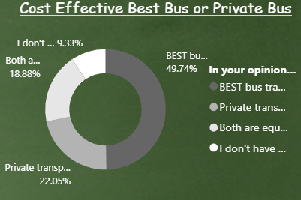

1. BEST Bus Preference: The largest portion of respondents (49.74%) believe that the BEST bus transportation system is more cost-effective.
2. Private Transportation: 22.05% of respondents think that private transportation systems are more cost-effective.
3. Equal Cost-Effectiveness: 18.88% of those surveyed believe that both BEST bus and private transportation systems are equally cost-effective.
4. Uncertainty: 9.33% of respondents indicated that they don't have an idea about the comparative cost-effectiveness.
5. Clear Majority: There's no overwhelming consensus, but the BEST bus system is viewed as more cost-effective by nearly half of the respondents

TRAVEL PREFERENCES:

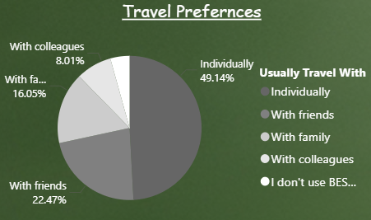

1. Individual travel is the most common preference, with 49.14% of users traveling alone. This suggests that nearly half of the service's customers are using it for personal, independent travel.
2. Traveling with friends is the second most popular option at 22.47%, indicating that the service is also frequently used for social outings or group trips.
3. Family travel accounts for 16.05% of usage, showing that the service is also utilized for family outings or trips.
4. A small percentage (8.01%) use the service to travel with colleagues, which might represent commuters or business-related travel.
5. Interestingly, 4.32% of respondents indicated that they don't use the BEST Bus Transportation Service at all. This could represent a potential area for growth or improvement in service to attract these non-users.

TRAVELLED BY DOUBLE DECKER BUS

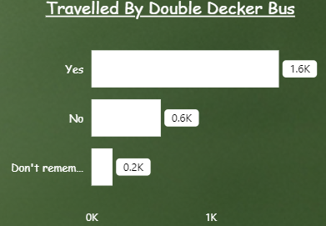

1. **Yes**: 1576 responses
2. **No**: 583 responses
3. **Don't remember**: 177 responses

PRIVATE TRANSPORT SATISFICATION:

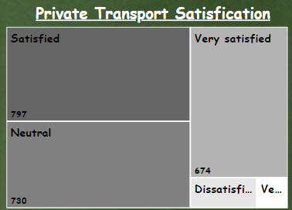

* Very satisfied: 797 responses
* Satisfied: 730 responses
* Neutral: 674 responses
* Dissatisfied: 92 responses
* Very dissatisfied: 43 responses

The majority of responses fall within the "Very satisfied" and "Satisfied" categories, indicating a generally positive perception of private transport among the participants.

IMPROVMENTS FOR BEST BUS

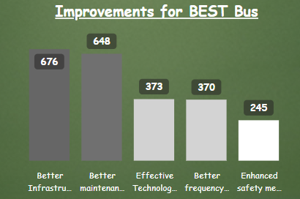

1. **Better Infrastructure**: 676
2. **Better maintenance of vehicles**: 648
3. **Effective Technological Changes**: 373
4. **Better frequency of Buses**: 370
5. **Enhanced Safety Measures**: 245

'Better Infrastructure' and 'Better maintenance of vehicles' are considered the most critical areas for improvement, receiving the highest values. In contrast, 'Enhanced Safety Measures' is seen as less critical compared to the other factors, as indicated by its lower value.

BEST BUS V/S PRIVATE TRANSPORT

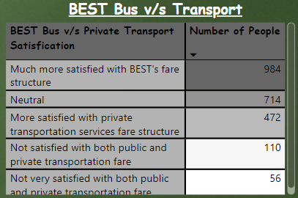

1. Highest satisfaction: The largest group (984 people) is "Much more satisfied with BEST's fare structure", indicating a strong preference for BEST bus fares over private transport options.
2. Neutral stance: A significant number (714 people) remain neutral, suggesting that for many, there's no clear advantage between BEST and private transport fares.
3. Private transport preference: 472 people are more satisfied with private transportation services' fare structure, showing there's still a substantial group that prefers alternatives to BEST.
4. Dissatisfaction: A total of 166 people (110 + 56) are not satisfied with both public and private transportation fares, indicating a small but notable group that finds issues with all available options.
5. Overall sentiment: When combining the "Much more satisfied" and "More satisfied" categories, there's a clear lean towards BEST bus services (984) compared to private transport (472).

IMPORTANCE OF BEST BUS [CONNECTING DIFFERENT POINTS OF THE CITY]

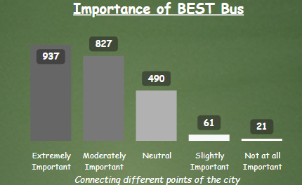

* **Extremely Important**: This category has the highest number of responses, with a total of 937, indicating that a significant number of respondents consider the BEST Bus service extremely crucial for city connectivity.
* **Moderately Important**: The second highest, with 827 responses, suggesting that many people rely on the service but may have alternatives or less dependency compared to the first group.
* **Neutral**: This category has 490 responses, indicating a considerable number of respondents are indifferent or neutral about the importance of the service.
* **Slightly Important**: Fewer respondents, totalling 61, find the service slightly important, which might suggest limited use or preference for other modes of transportation.
* **Not at all Important**: The least, with only 21 responses, showing that a very small segment of the population does not find the BEST Bus service important at all.

IMPORTANCE OF BEST BUS [ECONOMIC DEVELOPMENT]

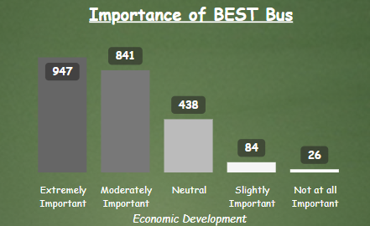

1. Overall Positive Perception: The majority of respondents view BEST Bus as important for economic development, with the highest numbers in the "Extremely Important" and "Moderately Important" categories.
2. Strong Support: 947 respondents consider BEST Bus "Extremely Important" for economic development, which is the highest category. This suggests a significant portion of the population recognizes the critical role of public transportation in economic growth.
3. Solid Backing: The second highest category is "Moderately Important" with 841 respondents, reinforcing the overall positive sentiment towards BEST Bus's economic impact.
4. Neutral Stance: A considerable number (438) remain neutral, which could indicate a segment of the population that is unsure about or hasn't experienced direct economic benefits from the bus service.
5. Limited Opposition: Very few respondents consider BEST Bus as "Not at all Important" (26) or only "Slightly Important" (84) for economic development. This shows minimal opposition or scepticism about its economic value.

IMPORTANCE OF BEST BUS [PROMOTION OF TOURISM]

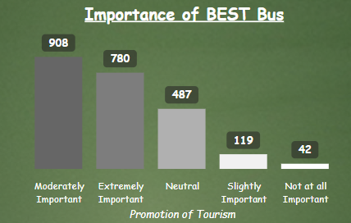

* Moderately Important" with a value of 908
* "Extremely Important" with a value of 780
* "Neutral" with a value of 487
* "Slightly Important" with a value of 119
* "Not at all Important" with a value of 42
* The BEST Bus is perceived as important for promoting tourism, with the majority of respondents rating it as "Moderately Important" or "Extremely Important." The data suggests a positive view of the bus service's role in tourism.

IMPORTANCE OF BEST BUS [EMPLOYEMENT GENERATION]

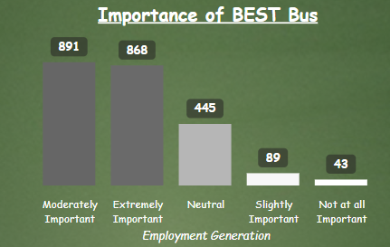

The graph shows that most respondents find the BEST Bus service either "Moderately Important" (891) or "Extremely Important" (868) for employment generation. There's a significant drop to those who are "Neutral" (445), and much fewer respondents find it only "Slightly Important" (89) or "Not at all Important" (43).

Based on the graph, it's clear that the BEST Bus service is considered highly important for employment generation by a majority of respondents.

IMPORTANCE OF BEST BUS [QUICK MOBILITY OF PEOPLE]

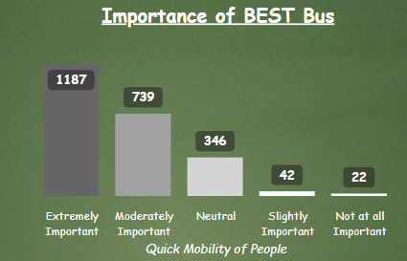

* Overwhelming importance: The majority of respondents consider BEST Bus to be extremely important, with 1,187 people in this category. This suggests that BEST Bus plays a crucial role in the city's transportation infrastructure.
* Strong overall positive perception: Combining the "Extremely Important" and "Moderately Important" categories accounts for 1,926 responses, which is a significant majority of the total.
* Limited negative perception: Only a small fraction (64 respondents in total) consider BEST Bus to be "Slightly Important" or "Not at all Important", indicating very low negative sentiment towards the service.
* Neutral stance: There is a moderate number of neutral responses (346), suggesting that some people neither strongly favor nor oppose the BEST Bus system.
* Gradual decline: The graph shows a clear step-down pattern from "Extremely Important" to "Not at all Important", indicating a consistent decrease in the number of respondents as the perceived importance decreases.

IMPORTANCE OF BEST BUS [REDUING TRAFFIC]

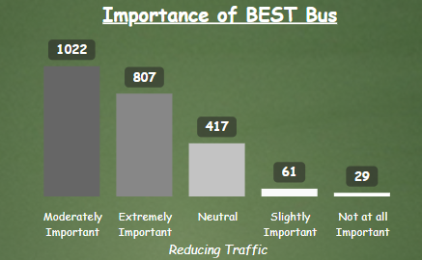

* Moderately Important: This category has the highest number of responses at 1022, indicating that a large portion of respondents consider the BEST Bus service significantly important, but not crucial.
* Extremely Important: The second highest with 807 responses, suggesting a substantial number of people view the service as essential.
* Neutral: 417 responses in this category, showing a considerable number of respondents are indifferent about the importance of the service.
* Slightly Important: 61 respondents find the service slightly important, indicating a small segment with limited reliance on or preference for the service.
* Not at all Important: The least, with only 29 responses, demonstrating that very few people consider the BEST Bus service unimportant.

IMPORTANCE OF BEST BUS [DECREASING POLLUTION LEVELS]

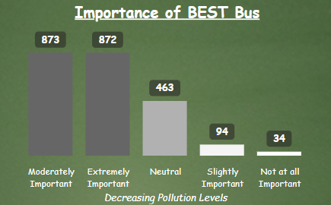

* Moderately Important: The highest category with 873 responses, indicating that a large number of people consider BEST Bus moderately important for reducing pollution.
* Extremely Important: Very close second with 872 responses, suggesting that nearly an equal number of respondents view BEST Bus as crucial for pollution reduction.
* Neutral: 463 responses in this category, representing a significant number of people who are indifferent or unsure about BEST Bus's role in decreasing pollution.
* Slightly Important: 94 respondents find the service slightly important for pollution reduction, a small but noticeable segment.
* Not at all Important: The least with 34 responses, showing that very few people consider BEST Bus unimportant for reducing pollution.

OPINION ON CHANGES OF BEST BUS FROM 2019 [ADAPTATION OF TECHNOLOGY]

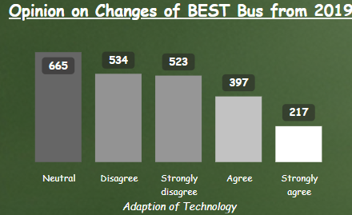

* Neutral: 665 responses - The highest number, indicating many people don't have a strong opinion or haven't noticed significant changes.
* Disagree: 534 responses - The second-highest category, suggesting a substantial number of people are not satisfied with the technological changes.
* Strongly disagree: 523 responses - Very close to the "Disagree" category, reinforcing the negative sentiment about technological adoption.
* Agree: 397 responses - A smaller group that approves of the technological changes.
* Strongly agree: 217 responses - The smallest group, but still indicating some strong support for the changes.

OPINION ON CHANGES OF BEST BUS FROM 2019 [DECREASE IN FAIR]

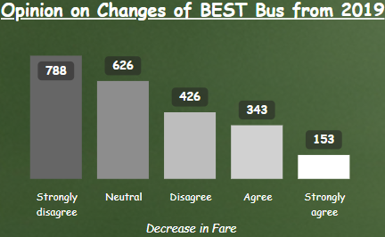

1. Strongly disagree: 788 responses - The highest category, indicating a large number of people strongly oppose the fare changes.
2. Neutral: 626 responses - The second-highest category, suggesting many people don't have a strong opinion or haven't been significantly affected by the fare changes.
3. Disagree: 426 responses - A substantial number also disagree with the fare changes, though not as strongly as the first group.
4. Agree: 343 responses - A smaller group that approves of the fare decrease.
5. Strongly agree: 153 responses - The smallest group, indicating minimal strong support for the fare changes.

OPINION ON CHANGES OF BEST BUS FROM 2019 [ELECTRIFICATION OF BUSES]

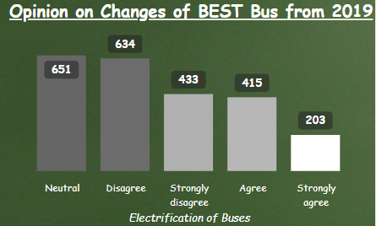

* **Neutral (651)**: The largest group is indifferent, suggesting the changes haven't had a strong impact, either positive or negative.
* **Disagree (634)** and **Strongly Disagree (433)**: A significant portion is dissatisfied, possibly due to issues with implementation or service.
* **Agree (415)** and **Strongly Agree (203)**: A smaller group supports the changes, likely recognizing benefits such as sustainability.

Overall, there’s more neutral or negative sentiment, indicating room for improvement in public perception of the bus electrification.

OPINION ON CHANGES OF BEST BUS FROM 2019 [FREQUNCEY OF AC BUSES]

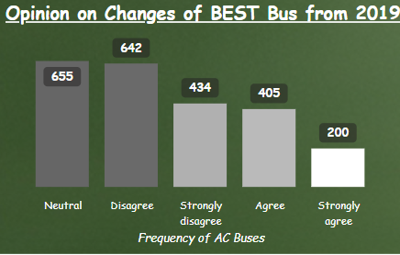

* **Neutral (655)**: Most respondents are indifferent to the changes, indicating that the adjusted AC bus frequency hasn't strongly impacted their experience.
* **Disagree (642)** and **Strongly Disagree (434)**: A significant portion of respondents are dissatisfied with the frequency, suggesting that many feel it is either insufficient or poorly managed.
* **Agree (405)** and **Strongly Agree (200)**: A smaller group approves of the changes, potentially viewing the new frequency as an improvement.

Overall, the majority of respondents are neutral or negative about the changes in AC bus frequency, signaling potential concerns that may need to be addressed.

OPINION ON CHANGES OF BEST BUS FROM 2019 [MAINTAINACE OF BUSES]

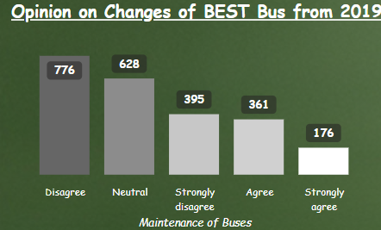

* **Disagree (776)** and **Strongly Disagree (395)**: A large majority are dissatisfied with the maintenance of the buses, indicating significant concerns over upkeep and service quality.
* **Neutral (628)**: Many respondents are indifferent, suggesting that the changes in bus maintenance have neither positively nor negatively impacted their experience.
* **Agree (361)** and **Strongly Agree (176)**: A smaller group views the maintenance positively, implying that some improvements may have been noticed, though not widely acknowledged.

OPINION ON CHANGES OF BEST BUS FROM 2019 [SAFETY AND PROTECTION]

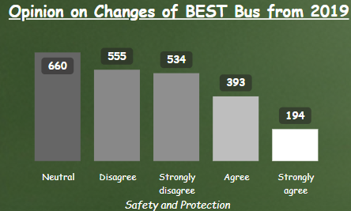

* **Neutral Opinions Dominate**: The highest number of respondents (660) indicated a neutral stance, suggesting that a significant portion of people are indifferent to the changes regarding safety and protection.
* **More Negative Feedback than Positive**:
* **Disagree (555)** and **Strongly Disagree (534)** together represent a significant portion of respondents, showing that more people had negative views about the changes than those who were positive.
* In contrast, only **393 people agree** and **194 strongly agree**, indicating that positive opinions are less common.
* **Low Strong Agreement**: With only 194 respondents strongly agreeing, it seems that a minority of people fully support the changes made to the BEST bus services' safety and protection features.

OPINION ON CHANGES OF BEST BUS FROM 2019 [CONNECTING DIFFERENT LOCATIONS IN THE CITY]

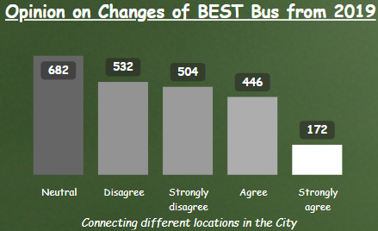

* **Neutral Responses are the Majority**: A total of **682 respondents** expressed a neutral opinion. This indicates that most people neither favor nor oppose the changes related to connectivity across different city locations.
* **Negative Opinions Outweigh Positive Ones**:
* A combined **532 respondents disagree** and **504 strongly disagree** with the changes, showing a stronger negative sentiment about how well the BEST bus connects different locations.
* Only **446 respondents agree** and **172 strongly agree**, indicating that positive feedback is significantly lower than negative feedback.
* **Strong Disagreement**: The number of people who **strongly disagree (504)** with the changes is close to the number who **disagree (532)**, highlighting dissatisfaction with the connectivity improvements.

SERVICE RATING OF BEST BUS [FREE TRAVEL FACILITY]

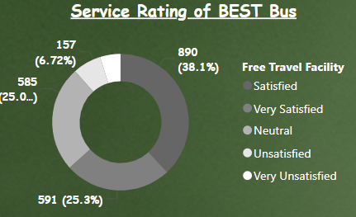

* **Satisfaction Levels**:
* **Satisfied (38.1%)**: The largest proportion, **890 respondents**, are satisfied with the free travel facility, showing a generally positive reception.
* **Very Satisfied (25.3%)**: A significant portion, **591 respondents**, are very satisfied, further emphasizing positive sentiment.
* **Neutral Stance**:
* **585 respondents (25.04%)** are neutral, indicating that about a quarter of the participants have neither positive nor negative views on the free travel facility.
* **Dissatisfaction**:
* **157 respondents (6.72%)** are unsatisfied.
* **113 respondents (4.84%)** are very unsatisfied.

SERVICE RATING OF BEST BUS [BUS OPERATOR/TRAFFIC CONTROL HELPLINE]

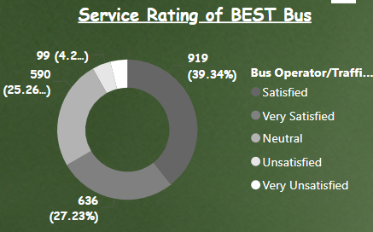

1. Satisfied: 919 respondents (39.34%)
2. Very Satisfied: 636 respondents (27.23%)
3. Neutral: 590 respondents (25.26%)
4. Unsatisfied: 99 respondents (4.24%)
5. Very Unsatisfied: 92 respondents (3.94%)

Key insights:

1. Overall positive sentiment: The majority of users (66.57%) are either satisfied or very satisfied with the service, which is a good indicator of customer contentment.
2. Low dissatisfaction: Only a small portion of users (8.18%) expressed dissatisfaction, with very few being very unsatisfied.

SERVICE RATING OF BEST BUS [CHALO- LIVE BUS TRACKING OR BEST PRAWAS (MOBILE APPLICATION)]

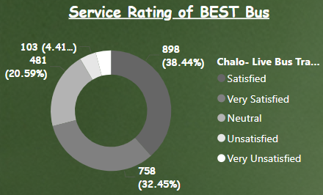

1. Satisfied: 898 respondents (38.44%)
2. Very Satisfied: 758 respondents (32.45%)
3. Neutral: 481 respondents (20.59%)
4. Unsatisfied: 103 respondents (4.41%)
5. Very Unsatisfied: 96 respondents (4.11%)

Key insights:

1. High satisfaction rate: A substantial majority (70.89%) of users are either satisfied or very satisfied with the live bus tracking service, indicating strong overall performance.
2. Low dissatisfaction: Only 8.52% of users expressed dissatisfaction, with a fairly even split between unsatisfied and very unsatisfied.

SERVICE RATING OF BEST BUS [COMPLAINT REDRESSAL]

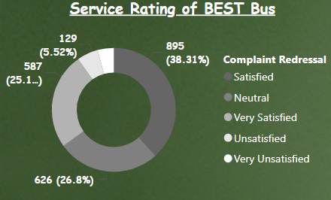

1. Satisfied: 895 respondents (38.31%)
2. Neutral: 626 respondents (26.8%)
3. Very Satisfied: 587 respondents (25.13%)
4. Unsatisfied: 129 respondents (5.52%)
5. Very Unsatisfied: 99 respondents (4.24%)

Key insights:

1. Overall positive sentiment: 63.44% of users are either satisfied or very satisfied with the complaint redressal system, indicating generally good performance.
2. Significant neutral feedback: Over a quarter (26.8%) of respondents are neutral, suggesting room for improvement to convert these users to satisfied customers.
3. Low dissatisfaction: Only 9.76% of users expressed dissatisfaction, with slightly more being unsatisfied than very unsatisfied.

SERVICE RATING OF BEST BUS [CONCESSIONAL FARE]

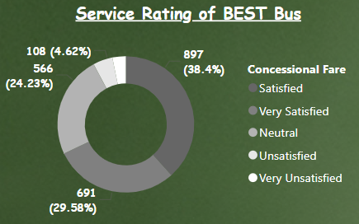

1. Satisfied: 897 respondents (38.4%)
2. Very Satisfied: 691 respondents (29.58%)
3. Neutral: 566 respondents (24.23%)
4. Unsatisfied: 108 respondents (4.62%)
5. Very Unsatisfied: 74 respondents (3.17%)

Key insights:

1. High satisfaction rate: A significant majority (67.98%) of users are either satisfied or very satisfied with the concessional fare system, indicating strong overall approval.
2. Low dissatisfaction: Only 7.79% of users expressed dissatisfaction, with slightly more being unsatisfied than very unsatisfied.

SERVICE RATING OF BEST BUS [COVERAGE OF BEST BUS ACROSS MUMBAI]

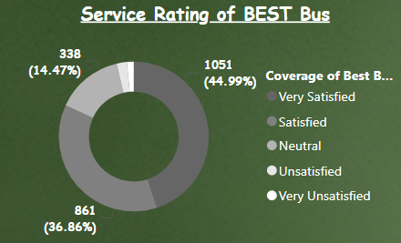

1. Very Satisfied: 1051 respondents (44.99%)
2. Satisfied: 861 respondents (36.86%)
3. Neutral: 338 respondents (14.47%)
4. Unsatisfied: 52 respondents (2.23%)
5. Very Unsatisfied: 34 respondents (1.45%)

Key insights:

1. Overwhelming positive sentiment: An impressive 81.85% of users are either very satisfied or satisfied with the bus coverage, indicating excellent service reach.
2. Very high satisfaction: Nearly half of all respondents (44.99%) are very satisfied, which is a strong indicator of comprehensive coverage.
3. Low dissatisfaction: Only a small fraction (about 3.68%) of users expressed dissatisfaction, with very few being unsatisfied.

SERVICE RATING OF BEST BUS [FARE STRUCTURE OF THE BEST BUS]

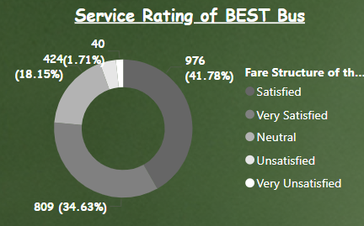

1. Satisfied: 976 respondents (41.78%)
2. Very Satisfied: 809 respondents (34.63%)
3. Neutral: 424 respondents (18.15%)
4. Unsatisfied: 87 respondents (3.72%)
5. Very Unsatisfied: 40 respondents (1.71%)

Key insights:

1. High satisfaction rate: A substantial majority (76.41%) of users are either satisfied or very satisfied with the fare structure, indicating that pricing is well-received by most passengers.
2. Strong positive sentiment: The largest segment (41.78%) is satisfied, closely followed by very satisfied (34.63%), showing that the fare structure meets or exceeds expectations for most users.
3. Low dissatisfaction: Only 5.43% of users expressed dissatisfaction, with very few being very unsatisfied.

SERVICE RATING OF BEST BUS [FREQUENCY OF THE BEST BUS IN YOUR LOCALITY]

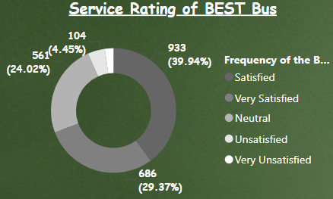

1. Satisfied: 933 respondents (39.94%)
2. Very Satisfied: 686 respondents (29.37%)
3. Neutral: 561 respondents (24.02%)
4. Unsatisfied: 104 respondents (4.45%)
5. Very Unsatisfied: 52 respondents (2.23%)

Key insights:

1. High satisfaction rate: A significant majority (69.31%) of users are either satisfied or very satisfied with the frequency of BEST Bus service, indicating that the service schedule is generally meeting the needs of most passengers.
2. Strong positive sentiment: The largest segment (39.94%) is satisfied, followed closely by very satisfied (29.37%), showing that the bus frequency meets or exceeds expectations for a large portion of users.
3. Low dissatisfaction: Only 6.68% of users expressed dissatisfaction, with very few being very unsatisfied (2.23%).

SERVICE RATING OF BEST BUS [PASSENGER REFUND CLAIMS]

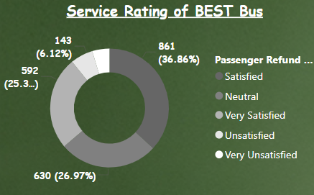

1. Satisfied: 861 respondents (36.86%)
2. Neutral: 630 respondents (26.97%)
3. Very Satisfied: 592 respondents (25.34%)
4. Unsatisfied: 143 respondents (6.12%)
5. Very Unsatisfied: 110 respondents (4.71%)

Key insights:

1. Positive overall satisfaction: A majority (62.20%) of users are either satisfied or very satisfied with the passenger refund claims process, indicating that the system is generally meeting customer expectations.
2. Room for improvement: A significant portion (26.97%) of respondents are neutral, suggesting there's potential to enhance the refund process to convert these users to satisfied customers.
3. Low dissatisfaction: Only 10.83% of users expressed dissatisfaction, with a small percentage being very unsatisfied. This indicates that major issues with refund claims are relatively uncommon.

SERVICE RATING OF BEST BUS [QUALITY OF SERVICE BY BEST BUS IN MUMBAI]

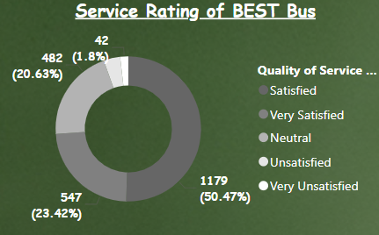

1. Satisfied: 1179 respondents (50.47%)
2. Very Satisfied: 547 respondents (23.42%)
3. Neutral: 482 respondents (20.63%)
4. Unsatisfied: 86 respondents (3.68%)
5. Very Unsatisfied: 42 respondents (1.80%)

Key insights:

1. High satisfaction rate: A substantial majority (73.89%) of users are either satisfied or very satisfied with the quality of service, indicating that BEST Bus is meeting or exceeding expectations for most passengers in Mumbai.
2. Strong positive sentiment: The largest segment (50.47%) is satisfied, with nearly a quarter (23.42%) being very satisfied, showing that the service quality is well-received by most users.
3. Low dissatisfaction: Only 5.48% of users expressed dissatisfaction, with very few being very unsatisfied. This suggests that major service quality issues are relatively rare.

SERVICE RATING OF BEST BUS [RESERVATION OF SEATS]

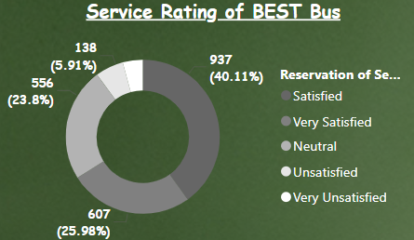

1. Satisfied: 937 respondents (40.11%)
2. Very Satisfied: 607 respondents (25.98%)
3. Neutral: 556 respondents (23.8%)
4. Unsatisfied: 138 respondents (5.91%)
5. Very Unsatisfied: 98 respondents (4.2%)

Key insights:

1. High satisfaction rate: A significant majority (66.09%) of users are either satisfied or very satisfied with the seat reservation system, indicating that it generally meets the needs of most passengers.
2. Strong positive sentiment: The largest segment (40.11%) is satisfied, with over a quarter (25.98%) being very satisfied, showing that the reservation process is well-received by most users.
3. Low dissatisfaction: Only 10.11% of users expressed dissatisfaction, with a small percentage being very unsatisfied. This suggests that major issues with seat reservations are relatively uncommon.

SERVICE RATING OF BEST BUS [SAFETY WHILE TRAVELING WITH BEST BUS]

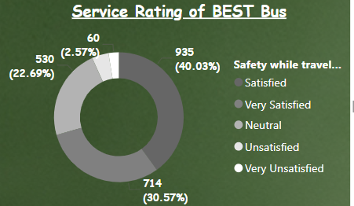

1. Satisfied: 935 respondents (40.03%)
2. Very Satisfied: 714 respondents (30.57%)
3. Neutral: 530 respondents (22.69%)
4. Unsatisfied: 97 respondents (4.15%)
5. Very Unsatisfied: 60 respondents (2.57%)

Key insights:

1. High satisfaction rate: A substantial majority (70.60%) of users are either satisfied or very satisfied with the safety while traveling on BEST Bus, indicating that passengers generally feel secure during their journeys.
2. Strong positive sentiment: The largest segment (40.03%) is satisfied, with nearly a third (30.57%) being very satisfied, showing that safety measures are well-received by most users.
3. Low dissatisfaction: Only 6.72% of users expressed dissatisfaction, with a small percentage being very unsatisfied. This suggests that major safety concerns are relatively uncommon.

SERVICE RATING OF BEST BUS [BUS PASS]

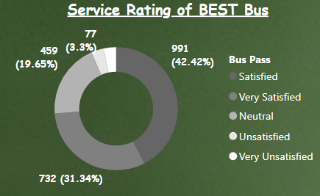

1. Satisfied: 991 respondents (42.42%)
2. Very Satisfied: 732 respondents (31.34%)
3. Neutral: 459 respondents (19.65%)
4. Unsatisfied: 77 respondents (3.3%)
5. Very Unsatisfied: 77 respondents (3.3%)

Key insights:

1. High satisfaction rate: A substantial majority (73.76%) of users are either satisfied or very satisfied with the BEST Bus service, indicating that passengers generally have a positive experience.
2. Strong positive sentiment: The largest segment (42.42%) is satisfied, with nearly a third (31.34%) being very satisfied, showing that the service is meeting the expectations of most users.
3. Low dissatisfaction: Only 6.6% of users expressed dissatisfaction, with equal percentages being unsatisfied and very unsatisfied. This suggests that major service issues are relatively uncommon.